# PYTHON MINI PROJECT

PUZZLE GAME

# INT-213

**Submitted in partial fulfillment of the requirements for the award of degree of B.Tech**

(Computer Science Engineering)

SUBMITTED TO: **Mr. Ishan Kumar**

“SCHOOL OF COMPUTER SCIENCE AND ENGINEERING”

LOVELY PROFESSIONAL UNIVERSITY PHAGWARA, PUNJAB



**SUBJECT NAME: PYTHON PROGRAMMING COURSE CODE: INT – 213**

**SECTION: K21PP**

**SUBMITTED BY:**

|  |  |  |  |
| --- | --- | --- | --- |
| S.NO | Name | Registration No. | Roll No. |
| 1. | Sohib Ahammed | 12103157 | RK21PP07 |
| 2. | Dishant Sharma | 12103117 | RK21PP08 |
| 3. | Shah Arsalan | 12102195 | RK21PP09 |

INDEX:

1. Introduction
2. Project Description
3. Python Module
4. Button Functions
5. Module Wise Description
6. Result Screenshot
7. Conclusion
8. References

**INTRODUCTION**

**Project Title:** Design a Puzzle Game in which various letters will be shown in a table and he/she can move horizontally, vertically, or diagonally to make meaningful words.

**Project Description:**

The minimum requirement of GUI as follows:

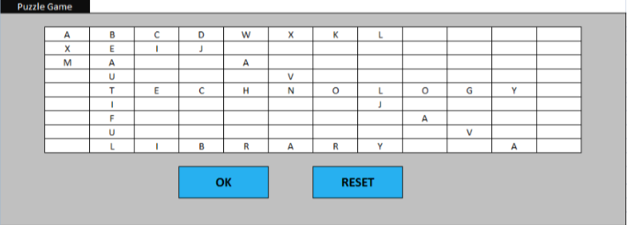

In this project we are going to develop a puzzle game which is GUI based using python programming language.

Word games (also called word game puzzles) are spoken or board games often designed to test ability with language or to explore its properties. Word games are generally used as a source of entertainment but can additionally serve an educational purpose. Word games are an enjoyable activity to test your vocabulary knowledge and improve your brain functions. It is not only a great way to relieve stress and pass the time, but also a great exercise for your brain.

**PROJECT DESCRIPTION**

In this word game a player must guess a word. Game will consist of table with many alphabets set in a random order and many English meaningful words will be hidden between them. We will have a table of alphabets and background will be of solid color. At the bottom we will have “OK” and “Reset” button along with the score label. After each guess, the score will either increase or remain the same depending on whether the letter is in the word list or not. You can play the game for unlimited time until you guess all the words.

**PYTHON MODULE**

For making the word puzzle game we use various functions, input, and python libraries but mainly we have used custom tkinter library.

Python GUI- Tkinter: - Python offers multiple options for developing GUI (Graphical User Interface). Out of all the GUI methods, tkinter is most used method. It is a standard Python interface to the Tk GUI toolkit shipped with Python. Python with tkinter outputs the fastest and easiest way to create the GUI applications. Creating a GUI using tkinter is an easy task.

Python GUI- CustomTkinter :- CustomTkinter is a python UI-library based on Tkinter, which provides new, modern and fully customizable widgets. They are created and used like normal Tkinter widgets and can also be used in combination with normal Tkinter elements. The widgets and the window colors either adapt to the system appearance or the manually set mode ('light', 'dark'), and all CustomTkinter widgets and windows support HighDPI scaling (Windows, macOS). With CustomTkinter you'll get a consistent and modern look across all desktop platforms (Windows, macOS, Linux).

To create a tkinter:

1.Importing the module-tkinter

2.Create the main window(container)

3.Add any number of widgets to the main window

4.Apply the event Trigger on the widgets

We can simply install the customtkinter library using the command pip install customtkinter

**BUTTON FUNCTIONS**

**OK** Button: -We must press the ok button after guessing a word. After pressing the OK button the score will either increase or remain the same.

**RESET** Button: - In RESET button, if user wants to reset the whole game, then he/she can press RESET button which will be on the bottom of that game in the right side of Ok button.

**MODULE WISE DESCRIPTION**

TKINTER

Installing Tkinter

Installation of tkinter is a must to start the project. Tkinter is a module that provides the easiest way to develop a graphical user interface. To install tkinter write the command mentioned below on your terminal window or cmd.

pip install tkinter

CTk(): It provides a custom library of basic elements of GUI widgets.

title(): It helps in setting the title of the screen

CHECKSPELL

This function is called when the user clicks the OK button.

The word inside the input field is stored inside a variable.

First we check if the word is present in the word list if it is not present then a message box is shown and the function returns.

If the word is present in the list, we check if the word is already submitted by the user by checking if it is present in the addedWord list.

If the word is not present is present in the addedWord the score global variable value is increased, and the word is added in the addedWord list.

Then we check the length of the addedWord list and the word_list if they are equal that means all the words are added so we can show the “All words guessed Dialog box” and quit the program.

CLEAR

The clear function is called when the user clicks the reset button

The score is reset to 0

The addedWord list is reset to an empty list

The input field is set to empty

INPUT HANDLER

This function is called when the user clicks any tile button in the puzzle with the argument as the letter in that button

The letter is inserted at the end of the input field by checking the current length of the word inside the input field

**RESULT SCREENSHOT**

**PROJECT CONTRIBUTION**

SOHIB AHAMMED: Filling the Contents inside the table of GUI.

DISHANT SHARMA: Creating different functions which are required in the project.

SHAH ARSALAN: Creating the GUI of the project .

**CONCLUSION**

In this project we have learned how to use python for building GUI project and how to implement it. Also, we have learned how to use the message box to display the messages, how to use the customtkinter library which makes the GUI more attractive. This game is for beginners learning to code in python and to give them a little brief about using strings, loops, and conditional statements. After guessing all the words, the game stops on its own. This puzzle game is successfully done using Tkinter by python. So, we have successfully developed a puzzle game with the knowledge of tkinter and python.

**REFRENCES**

GITHUB:

https://github.com/TomSchimansky/CustomTkinter